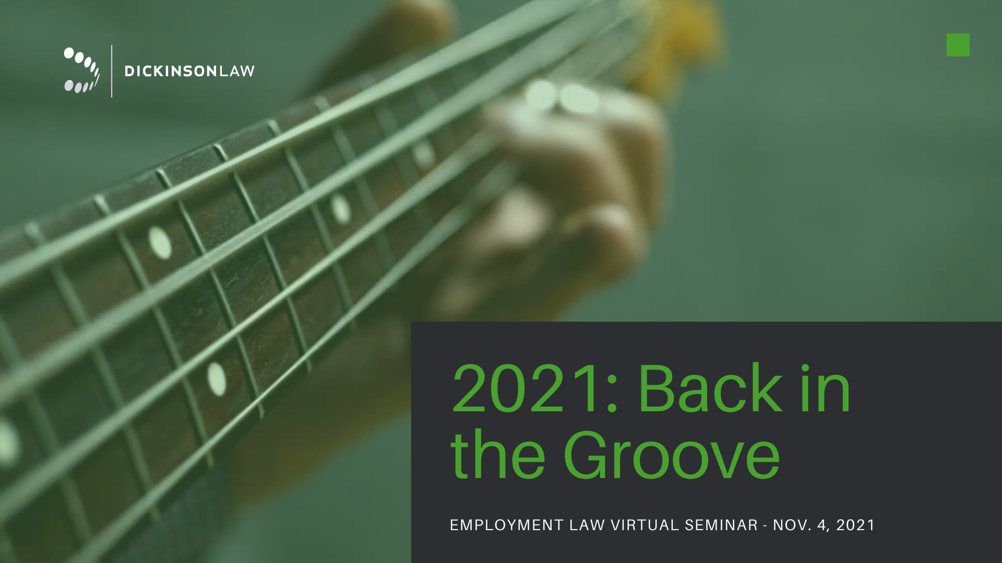
Play our SECRET WORD GAME with us during the Dickinson Law Virtual Employment Seminar!
Here's how:
- Listen for the secret words. Somewhere within each presentation (with the exception of guest presenter Desmund Adams’ presentation), we will show a slide with a secret word. Hint: it may be music-related!
- Enter the secret words in the box below.
- Email your completed worksheet to marketing@dickinsonlaw.com. That’s it! Correct and completed entries will be entered for a chance to win one of six prizes – a Phonesoap 3 or Docksy! The winners will be chosen at random and notified via email.
SECRET WORDS

My email address: __________________________________________

